Stephen Johnston
Electromagnetic research
Electric motor design log:

3/26/2018
Design begins for electric motor. I haven’t picked up the magnets yet, but I’ve began reading an explanation of the concepts. Research on how to 3d print also begins. I’m not sure if I can get Robert to help me out before the break ends, which is understandable.
UPDATE: Finished reading paper on brushless motor. 5-minute freak out phase begins.
3/27/2018
UPDATE: Found this video, it seems interesting enough to help my understanding of how it works.
https://www.youtube.com/watch?v=YsSm65DAcCg
UPDATE: Just finished the video, it gave some really important information not mentioned in the page. I think that measuring the weight and force generated by the magnets is a very important factor to make sure that our motor is not off balance.
3/28/2018
INVENTORY:
Cylindrical axle
Hollow (Toroid?) cylindrical in nature
21 Gauge wire
12 magnets.
UPDATE: 10 magnets. Two of them broke, one by applying a horizontal force to remove it from the stack. Another broke simply by it being attracted to other magnets. I would recommend providing some type of protective shielding while measuring. Although I don’t know what type.
Also, after all magnets are measured, I have a procedure to now follow when I order the next batch of magnets.
1. Wrap each magnet with a type of masking tape. This makes it easier to label and also decreases the magnetic force a fair amount. It might be enough to prevent them from breaking whenever they reconnect.
2. Take a scale and tape some type of –THIN!!--fulcrum device to the scale, then zero it. Make sure that the material is non magnetic. I used FR4, which is easily available for free.
3. First tape and then measure the magnet in the exact same spot at the end of the fulcrum. The goal isn’t necessarily to measure the weight of the object as much as to measure the weight of the object with respect to other magnets. Compare the weight of the magnets with other magnets. (Unfortunately the scale I used did not have more than 1 significant figure. I might have to use my scale at home)
4. Zero the scale and place a different magnet under the board. For higher accuracy, you can tape it to the same spot and simply place a piece of wood over the magnet for when you’re measuring the weight of the magnet.
5. Record this measured weight and multiply it by 9.8m/s, this is the distinct force placed upon the stationary magnet by the measured magnet. Compare these on a graph.
6. Attempt to symmetrically place the magnets around the motor when finished by their measured weight.

UPDATE: The sharpie I used is terrible and stained my clothes. Its not note worthy but it made me angry.

3/29/2018
I found a purchase link for the replacement magnets.

https://www.banggood.com/20pcs-N50-Grade-Strong-Block-Cuboid-Magnets-30-x-10-x-3mm-Rare-Earth-Neodymium-p-996556.html?cur_warehouse=CN

This one ships in 7-10 days. The best one so far.
https://www.ebay.com/itm/20Pcs-Super-Strong-Block-Cuboid-Magnets-30-x-10-x-3-mm-Rare-Earth-Neodymium-N50/281869623011?hash=item41a0bd1ee3:g:WgQAAOSwnH1WWe2P

I would have went for amazon but surprisingly there is not a single 30mm magnet I could find, of any grade.
As long as they can arrive in a timely fashion, I would recommend purchasing from here and then getting the wire from the EPL. The hollow cylinder and axle, I’m not sure about.
My reasoning for purchasing from here is because these magnets are not only very powerful but very easy to break. For example, I had the magnets separated about seven to eight inches away from each other as I was measuring them. The magnetic field was so strong even at that point that after a while the magnets began to combine.
This leads me to believe that anyone without proper experience is bound to break one or two of these.
Another possible option is to get someone experienced with solid works to expand the motor to 60mm in length. This would allow students to purchase the much more common magnets on Amazon and have 2 day shipping.

Things I’m not sure about: It may be possible that we can order the 60x10x3mm magnets and cut them in half. Apparently the coating, from what I can tell, is just for show. Since these magnets are really brittle, it might be easy to cut them apart.

3/30/2018
UPDATE: Motor is finished printing. A single important part failed and is being printed again. This seems to be a reoccurring issue. Maybe there’s a way that students could order the parts online and have them printed 3rd party. Other than that, the assembly of the rest of the motor begins.

UPDATE: There seems to be a thin film of the printing material around each part, its a little difficult to pry off but nothing has broken during my attempts. Luckily.

UPDATE: The magnets are an extremely tight fit, its important to mention this, they will not be taken out after placed in. Map out your magnet placement before putting them in

4/2/2018

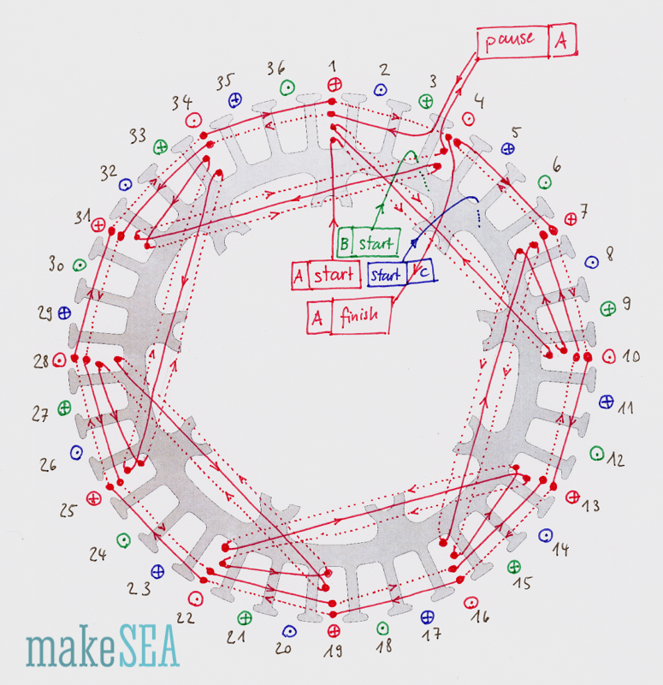
UPDATE: I had finished the wiring three days ago, but was unable to confirm my measurements. I then realized that my wiring was incorrect ( I was following the wrong diagram, more on this later)

Figure 1: Correct diagram
Now that I’ve restarted my wiring, I realized that luckily there is a fair amount of extra wire. I would recommend that students use a smaller gauge wire than the one provided. I’ve been cramping my hands trying to get all of it to fit.

UPDATE: motor constructed. I should mention that the windings that I used neglect that very outermost ring. The outermost ring is a series of smaller inductors inside the already large one. My reasoning for neglecting this is because there was not enough room to contain this ring under really any circumstance. The wire gauge is too high. One thing I noticed was the significant amount of friction in the motor. I’m not sure if the printer made the design too small or if this is simply due to the cables. I shaved down some of the magnet holders to reduce this. However, there is still a lot of friction.

UPDATE: Update, using an old credit card works very well for pushing the wires in without harming them. This reduced about 50% of the friction.

UPDATE: Just began to install the “Servo consistency master”

There isn’t much documentation on it. All websites repeat pretty much the same feature list and no installation tutorials. No datasheet either…

UPDATE: The servo consistency master only provides about 15ma of current. I don’t think this is enough to drive the motor, friction or not. Roadblock reached. I think I’ll have to check each individual phase, just to see if the motor rotates. In the mean time I measured the resistance for each wire. Its around .4-.5 ohms. Interestingly enough, this is significantly HIGHER resistance than what was measured online. This also interests me because I used less wire than the website did.

4/13/2018
UPDATE: Wound the v2 part of the stator with 22 gauge wiring. Works great! What doesn’t work great is that despite the parts being lined up from the outside, I didn’t realize that they have to wind up on the inside as well. I learned this the hard way and am rewinding. Oh well.
UPDATE: Finished rewinding. Next is to test it. There is friction but significantly less.

